

**Asset Practice Answers: Mathematics**

1. Look at the card pattern below.

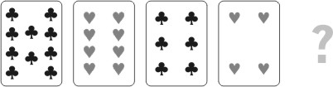

Which of the following should be the next card in this pattern?

A. 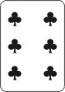 B. 

**C.** 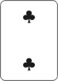 D. 

2. 5 years ago, Jack was 10 years old. Jill will be 10 years old next year. Who is the older of the two and by how many years?

**A. Jack is older by 6 years**

B. Jill is older by 10 years

C. Jill is older by 5 years

D. Jack is older by 15 years

3. Amit is using a bigger glass and Swati is using a smaller glass to fill the water bottle.

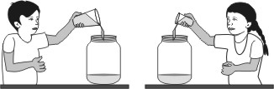

Amit fills the bottle in 5 turns. How many turns will Swati take to fill the same bottle?

A. exactly 5

**B. more than 5**

C. less than 5

D. She will never be able to fill the bottle with water using her glass.

4. See the number pattern in the shapes below:

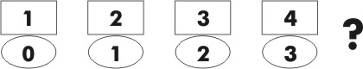

What comes next?

A. 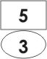 **B.** 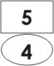

C. 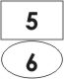 D. 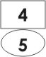

5. See the pattern below.

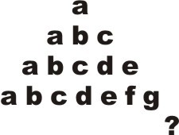

What will be the LAST letter in the next line of the pattern?

A. g

B. h

**C. i**

D. z

6. Here is a part of a children's rhyme:

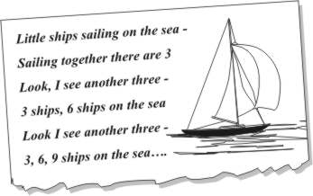

This rhyme can teach you

A. addition by 2's

B. multiplication table of 2

**C. multiplication table of 3**

D. addition by 6's

7. Mita first bought 33 chocolates for her son Yash's birthday. Later she thought more friends of Yash would come and she bought 15 more chocolates. Yash gave away 40 of the chocolates his mother bought, to his friends. How many chocolates remained?

A. 0

B. 7

**C. 8**

D. 25

8. Salil had 2 boxes of pencils. Each box had 4 red and 3 blue pencils. The total number of pencils that

Salil had is:

A. 7 + 2

**B. 7 🞩 2**

C. 12 🞩 2

D. 12 + 2

9. Which of these is true about the two numbers '95' and '495'?

A. 95 is 4 times 495.

B. 95 is 4 less than 495.

C. 495 is 4 times 95.

**D. 495 is 400 more than 95.**

10. What is 3 times 13?

A. 16

**B. 39**

C. 133

D. 313

11. A tailor has to put 5 buttons on a shirt. How many buttons will he need for 12 shirts?

A. 12 + 5

**B. 12** 🞩 **5**

C. 5 + 5 + 5 + 5 + 5

D. 12 🞩 12 🞩 12 🞩 12 🞩12

12. Shown here are the years in which Maruti started selling different models of cars.

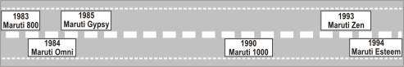

Which car was launched before Maruti 1000 but after Maruti 800?

A. Maruti Zen

**B. Maruti Omni**

C. Maruti Esteem

D. Maruti 1000



1. C: Can you see that a card with flowers alternates with a card with hearts? So the next card will have flowers on it. We have 10 flowers on the first card, then 8 hearts, then 6 flowers, 4 hearts,...Can you see that the number of flowers or hearts keep decreasing by 2? So the next card should have 2 flowers on it. So option C is the correct answer.

2. A: 5 years ago Jack was 10 years old. So now he is 10 + 5 = 15 years old. Next year he will be 16 years old. Jill will be10 years old next year. So Jack is older by 16 - 10 = 6 years.

3. B: Try this at home. Take a big glass and a smaller one and try to fill your water bottle. What do you observe? With which glass did you have to take more turns? Swati is using a smaller glass and so she would be pouring less water into the bottle each time isn't it? So she would need to take more turns than Amit to fill the bottle. So if Amit takes 5 turns, Swati would have to take more than 5 turns.

4. B: Study the pattern. Can you see that the numbers in the rectangle goes as 1, 2, 3, 4... So what would be the number in the next rectangle? 5 right? Look at the number in the oval. Is it related to the number in the rectangle in some way? It is one less than the number in the rectangle right? So if we have 5 in the rectangle, we will have 4 below it in the oval. So option B is the correct answer. In option C, the number in the oval (6) is 1 more than 5.

5. C: Study the pattern. How does it go? In the first line we have just one letter a. In the next line we have 2 more letters, b and c. In the third line we have 2 more letters, d and e. So to get the next line we add two more letters to a given line. The last line shown is a, b, c, d, e, f, g. To this we add two more letters h and i. So the last letter in the next line will be i. h comes just after g. Look at the last letters. Do they go a, b, c, d, ...So can the last letter in the line next to the one ending in g be h? No!

6. C: The rhyme teaches 3 + 3 ships is 6 ships. That is 2 threes are 6. 3 + 3 + 3 ships are 9 ships. 3 threes are 9. So the rhyme teaches you the multiplication table of 3.

7. C: Mita first bought 33 chocolates and then she bought 15 more. So she bought 33 + 15 = 48 chocolates in all. Of this Yash gave away 40 chocolates. So there are 48 - 40 = 8 chocolates left. You may possibly have done 40 - 15 = 25. That is not what we should do here. Try to understand what the question says before answering it.

8. B: There are 4 red pencils and 3 blue pencils in each box. That is, there are 4 + 3 = 7 pencils in each box. Salil has 2 such boxes. So the total number of pencils Salil had is 7 🞩 2. When you have 7 pencils each in two boxes, to find the total number of pencils, you do 7 + 7 or 7 🞩 2 and not 7 + 2.

9. D: What do you get if you add 400 to 95? 495, right? So 495 is 400 more than 95. What is 4 times 95? 95 + 95 + 95 + 95 = 380, which is not equal to 495. We write 4 times 95 as 4 🞩 95 and not as 495. Check if 4 times 495 is 95!

10. B: 3 times 13 is the same as 13 + 13 + 13. And 13 + 13 + 13 = 3 🞩13, which is 39. Hence B is the answer. 16 is 3 more than 13 and not 3 times 13. So A cannot be the answer.

11. B: A tailor has to put 5 buttons on a shirt. He has to put 5 + 5 = 2 🞩 5 buttons on two shirts. How many buttons he will need for 12 shirts? 12 🞩 5 buttons, right?

12. B: From the figure we can see that Maruti 800 was launched in 1983 and Maruti 1000 in 1990. So we need to look for a car that was launched after 1983, but before 1990, that is between 1983 and 1990. We see that Maruti Gypsy and Maruti Omni were launched after 1983, but before 1990. So option B, Maruti Omni is the correct answer. Maruti Esteem and Zen were launched after 1990.